**Project 7**

**PIC : Galang**

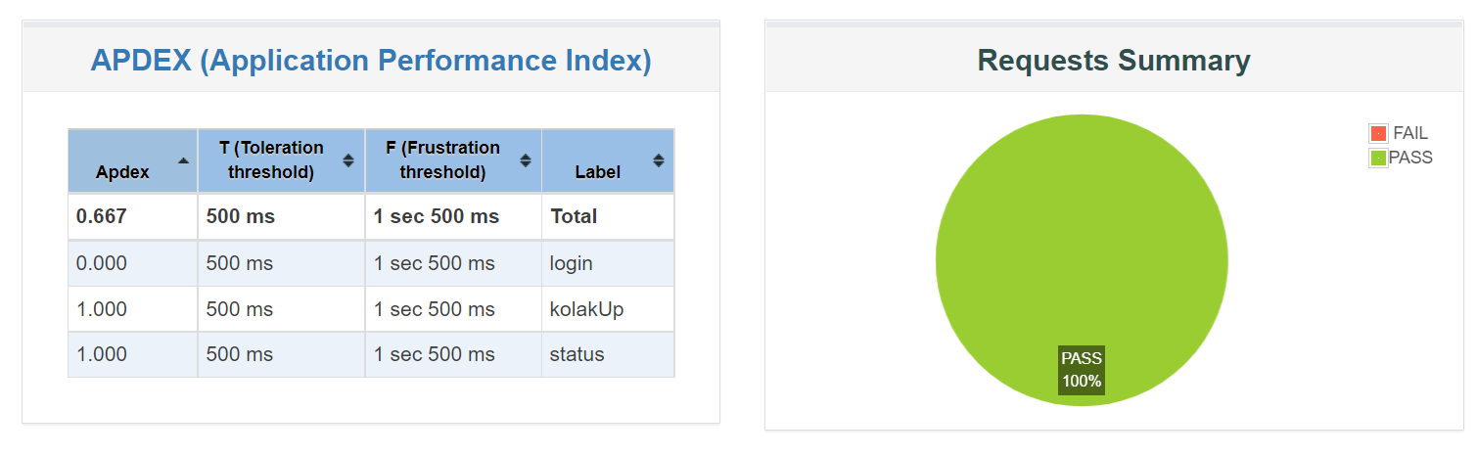

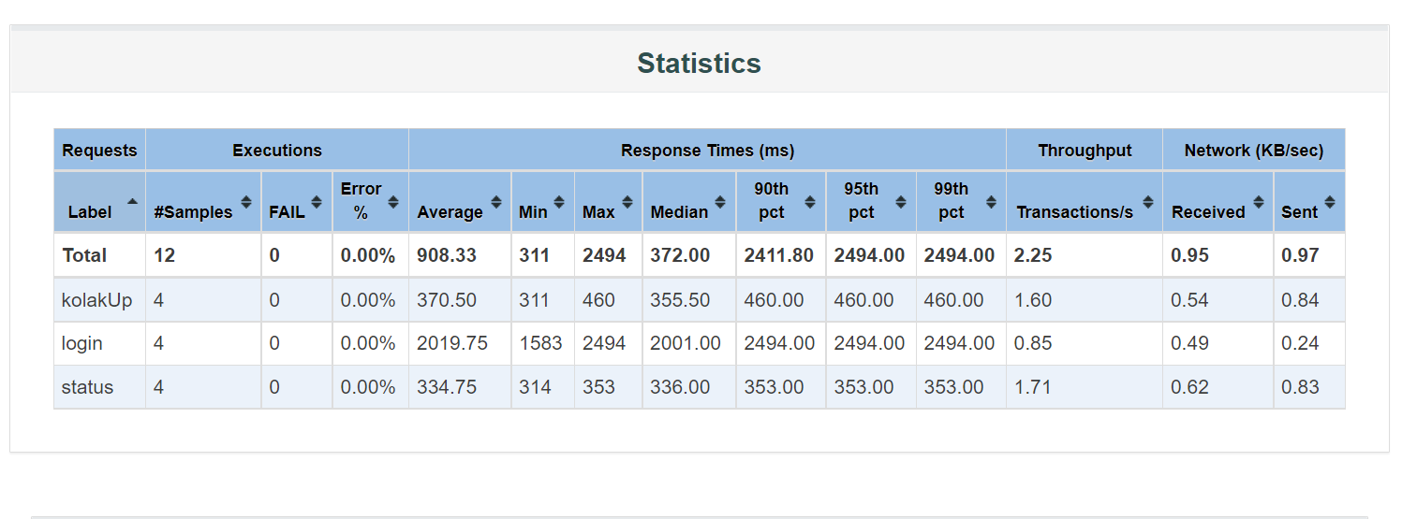

Average response time is around **908.33**ms for Kolak Project

Meanwhile, average vs 99% percentile for each end point is listed below

Error Rate is 0.00%

Login is 2019.75ms vs 2001.00ms

Status is 334.75ms vs 336.00ms

CPU usage

CPU usage vs RPS/throughput.

When we got 1.60s trx/s we got 40% CPU utilization

When we got 0.85s trx/s we got 20% CPU utilization

When we got 1.71s trx/s we got 39% CPU utilization

This is means that our application can handle 8.100 users per hour maximum